The College of New Jersey

Class Scheduling

The College of New Jersey  
Office of Records and Registration

2000 Pennington Road

Ewing, NJ 08628

Phone 609.771.2141

New Chair Information Outline

Records and Registration

Scheduling

Records & Registration Resources:

* Wes LaBar X2838 [scheduling, student enrollment and PAWS queries]
* Pamela Olliver X2837 [scheduling and student enrollment]
* Katie Caperna X2827 [Assistant Director for Enrollment/Transcripts]
* Nancy Eller X2883 [change of major]
* Maura Moore X2680 [Associate Director for Enrollment & Student Records]
* Galo Guerrero X3300 [Student Records Business Analyst]
* X2336 [Academic Advising & Student Records Sr. Business Analyst]
* Erica Connolly X2826 [Transcript, Imaging and Records Clerk]
* Robby Varghese X2312 [varghesr@tcnj.edu](mailto:varghesr@tcnj.edu) [Associate Director for Systems & Reporting]
* Billy Peitz X2373 [Reporting Analyst (BBA/BO)]
* Judi Cook- [cookju@tcnj.edu](mailto:cookju@tcnj.edu) [blended and online] Office of Instructional Design
* R:/RandRCampuswideInfo/Scheduling/......Exams, Roll Options, and Training Documents folders
* R:/RandRCampuswideInfo/Enrollment Database
* R:/RandRCampuswideInfo/ New Students
* R:/RandRCampuswideInfo/ Class List
* R:/RandRCampuswideInfo/Scheduling Resources/PS Help [documents]
* schedule@tcnj.edu -- write to the R&R Scheduling Team and provide documentation for requests

Scheduled Events [see Year-Long Scheduling Cycle to Support Yearly Planning on the R drive]:

* End of Add/Drop -Massed Exam Request sent to Departments
* Mid-term -Term Roll Request sent to Departments
* Mid-term -Registration; adjust reserve capacities/seat holds
* Priority Rooming -Schedule classes in “your” rooms for future terms at the beginning of scheduling cycles
* Mid-Summer -Freshman “Orientation”

Issues:

* Scheduling in general
  + R&R is responsible for assisting Departments in scheduling all classroom activities.
    - R&R and the Departments have priority over scheduling classrooms during class hours through at least the Add/Drop period. Classrooms are available to Conference & Event Services for scheduling in Book-It thereafter.
    - Priority rooming is designed to give the Departments greater control over their scheduling.
  + Scheduling non-class activities is normally scheduled through Book-It.
  + The scheduling cycle follows an annual pattern developed by the Deans. The Year-Long Scheduling Cycle to Support Yearly Planning for next year is attached.
* Scheduling is done on an annual basis. In the Fall of each year, scheduling is begun for the Fall, Spring and summer for the following year. Course roll options are recorded on the R-drive at R:/RandRCampuswideInfo/Scheduling/Roll Options
* Course Catalog
  + New Courses and significant modifications require a completed Course Approval Form. Upon receipt, R&R will create the new course. Please send an electronic copy (e.g. Word) of the course description so we can accurately add it to the course. We cannot copy and paste the description from a PDF.
  + New Topics should be requested of R&R by email. They will be added to the course catalog by R&R, and will then be available to the Departments to add to the class on the Basic Data tab. Topics will appear on the students’ transcripts.
  + Prerequisites and Co-requisites are set on courses and classes by R&R using requirement groups. Please request by email.
* Classes
  + Cancelling Classes
    - Cancelling classes removes the instructor and meeting pattern; drops the students and sends them an email notification automatically; an email is also automatically sent to the instructor, HR and R&R.
    - Print class roster or run roster & email query [TC_SR_CLASS_0024]
    - Classes may be deleted prior to registration for the term since no enrollment record could have been created. After the schedule is opened to students, please cancel unnecessary classes.
  + Topics classes must have a current topic on the basic data tab. Do not place on the meeting pattern tab.
  + Scheduling must be complete in order for security to know where students are and what buildings are occupied. Multiple meeting patterns are possible.
  + Instructors
    - Adjuncts cannot be added to class meeting patterns until fully processed in the Adjunct Contract system and HR
    - Instructor Access must be ‘Post’ in order to grade a class
    - Workload is normally automatic
  + Exams
    - An Exam Schedule Grid is prepared each term and a copy placed on the R drive.
    - The Massed Exam and Special Requests Form is circulated after the end of Drop/Add. There is limited space for massed exams.
    - A Snow Emergency Protocol has been developed for the Fall Exam Schedule which adds one day to the exam schedule if necessary.
  + Variable credit classes
    - Variable credit courses exist in the catalog. Most will be converted to a fixed number of units/credits when a given class (section) is set up. R&R must be notified to set the limit on the class prior to student registration or students will be enrolled at the minimum number of units/credits. Fixing this after students have enrolled is both time-consuming and creates billing problems. Early intervention is essential.
  + Special billing classes
    - R&R and Student Financial Services must be advised of any classes requiring special billing. A rate must be provided to Student Financial Services.
  + Liberal Learning classes are coordinated with Kit Murphy and Advising Resources in R&R
  + Notes, either canned or free-format, can be added to any class. Students will see the Notes when doing a class search.
  + Zero capping a class is not the preferred method of controlling enrollment. Use Reserved Capacities.
  + Add or Drop class consent required may be set on a class. It should be required on variable credit classes.
  + Reserved Capacities [seat holds] are used to reserve seats for selected groups of students during enrollment.
  + Class permissions may be handed out to students ahead of time to allow them to self-enroll.
  + Combined Sections [Crosslisting]
    - Classes must be combined by R&R; please request by email
    - Class meeting patterns may only be modified using the Schedule Class Meeting portion of the PAWS menu [rather than Maintain Schedule of Classes].
  + Grading
    - R&R creates the class grade rosters just prior to the end of the given session. All adjustments to the class roster must be made prior to the generation of the grade roster.
    - Instructors must enter the grades and ‘Post’ them in order to be effective.
  + Canvas is available for faculty and students. It is fed from PAWS nightly. Faculty who have been entered as the instructor in a class meeting pattern, with ‘Post’ access, will appear in PAWS the next day.
* Queries and reports
  + Public Queries in PAWS [TC_SR_...]

Navigation: Reporting Tools / Query Viewer

* + - TC_SR_CLASS_0012A Instr Class Schedule for Depts
    - TC_SR_CLASS_0012B Instr Class Schedule for Schls
    - TC_SR_CLASS_0012C Instr Class Summary for Depts
    - TC_SR_CLASS_0012D Instr Class Summary for Schls
    - TC_SR_CLASS_0035A class audit info TCSRCL0035A
    - TC_SR_CLASS_0024 cls roster w/ campus emails
    - TC_SR_CLASS_0024B cls roster w/ emails & majors
  + Favorites – Highlight the queries you use often
  + Business Objects Reporting
    - Standard Reports are placed on the S Drive [R:/RandRCampuswide Info/…]
      * Enrollment By Term
      * Graduation
      * Change of Major
      * Other

Faculty Menus:

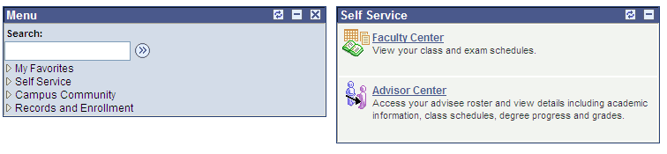

Chair Menus:

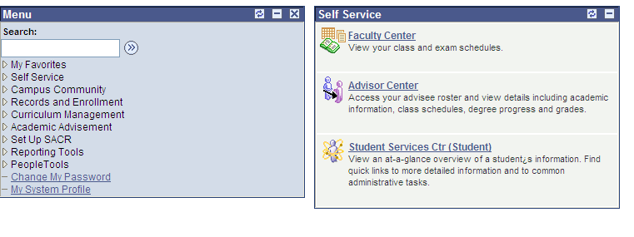

PAWS navigation from Main Menu

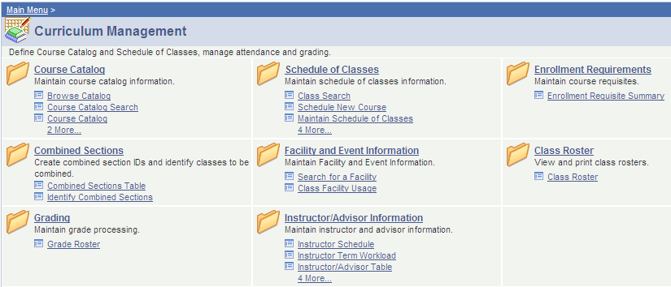

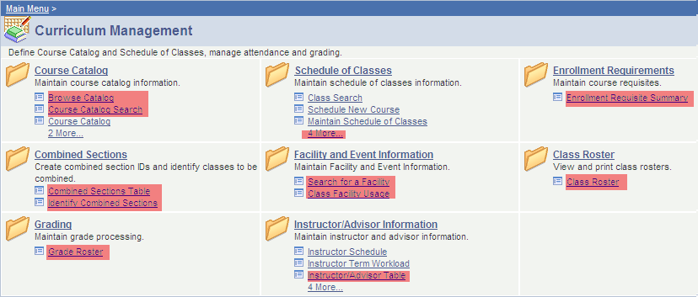

Highlighted menu options are search or inquiry only.





Chair Training Documents

How to Schedule a Lecture Class

How to Schedule a Lecture with a Lab

How to Schedule a Lecture with Oral Proficiency Hour

How to Add a Topic to a Class Section

Adding Attributes to a Class

How to Assign Zero Financial Hours to a Class

How to Select a Class Topic

How to Add an Instructor to a Class

Facility Event Usage

Finding a Room for Classes or Exams

How to Combine Classes

How to Reserve Seats in a Class for a Specific Student Population

How to Release Reserved Seats in a Class

How to Delete a Class Section

How to Delete a Class

How to Remove a Class Section

How to Print the Class Schedule

Setting up student specific class enrollment permissions

Setting Class Schedule to Print

Meeting Pattern, Instructor and Workload

Changing Class Status

Additional Reserve Capacity Information

Class Notes

Reserve Capacity (AKA Seatholds)

Enrollment Requisite Summary

How to Clear Cache

How to Add Blended and Online Courses

**How to Schedule a Lecture Class**

Navigation: Curriculum Management > Schedule of Classes > Schedule a New Course

1. Enter in the **Term** **Code** that the class is being offered, the **Subject Area** abbreviation of the class and the **Catalog Number** and then click **search.**
2. Under the **Basic Data** tab, most of the values will default.
   1. Select the appropriate **Session** value for this course (most courses are assigned value 1- Regular Academic Session).
   2. Change the **Class Section** equal to 01 (if this is the first lecture being scheduled, otherwise, follow the sequence).
   3. Set the **Component** equal to the appropriate lecture/seminar activity code associated with the course (LDI for Discussion Lecture, LEC for Lecture or SEM for Seminar).
   4. Set **Class Type** to Enrollment.
   5. Set **Associated Class** equal to 1 (if this is the first lecture being scheduled, otherwise, follow the sequence).
   6. Set **Campus** equal to either Main or Global.
   7. Verify **Class Topic**, **Equivalent Course Group**, & **Class Attributes** are correct.

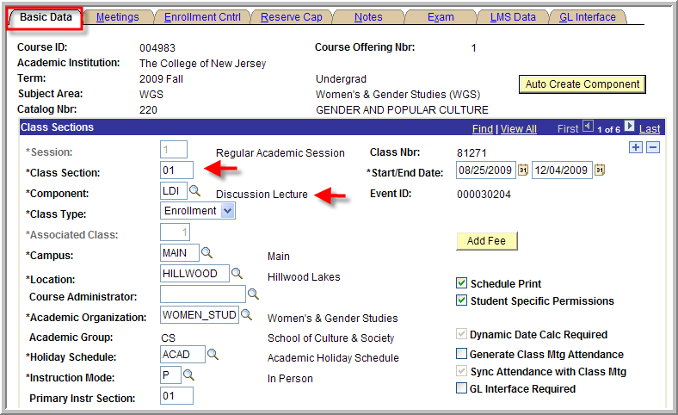

1. Click on the **Meetings** tab at the top.
   1. Use the magnifying glass next to **Facility ID** to select the classroom.
   2. Use the magnifying glass next to M**eeting Pattern** to select the meeting pattern value.
   3. Enter in the **Mtg Start** time and tab out of field to have **Mtg End** time automatically calculated.
   4. Under **Instructors for Meeting Pattern** in the **Assignment** tab, use the magnifying glass next **ID** to select the class instructor.
   5. Set **Access** to post.

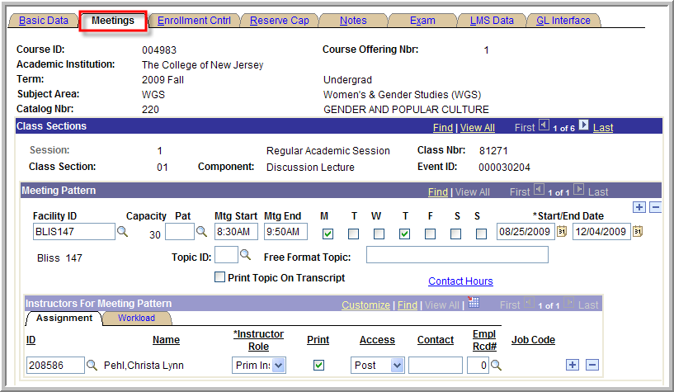

* 1. Under **Instructors for Meeting Pattern** click on the **Work Load** tab.
  2. Set **Assign Type** equal to Instructor
  3. Verify **Load Factor**. For 1 instructor load factor equals %100. For two instructors load factor equals 50% for each instructor. For three instructors the load factor equals 33.3 for each instructor.
  4. Verify the value in the **Workload** field is correct.
  5. Leave the **Auto Calc** box checked.

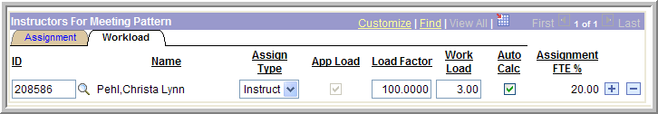

1. Click **Save**.
2. To add another lecture section, navigate back to the **Basic Data** tab and click on the **“+ sign”** under the **Class Section** heading. This will create a new row and you will need to repeat steps 1 through 4 again.

**How to Schedule a Lecture with a Lab**

When scheduling a lecture with a lab component, we will be using the following scheme for assigning section numbers: All lecture sections will be identified with a letter, with the first lecture in the sequence beginning with ‘A’. The corresponding labs will be identified with a numbering sequence beginning with ‘01’ and tied to the lecture by ending in the letter of the lecture. So for example, Lecture section ‘A’ will correspond to Lab section ‘01A’, ‘02A’, ‘03A’ etc. Lecture section ‘B’ will correspond to Lab section ‘01B’, ‘02B’, and ‘03B’, etc.

Navigation: Curriculum Management > Schedule of Classes > Maintain Schedule of Classes

(If the course has not yet been set up for the term navigate to Curriculum Management > Schedule of Classes > Schedule a New Course)

1. Set **Academic Institution** equal to **TCNJ1,** enter the **Term** code, the **Subject Area** abbreviation and **Catalog Number** for the course that is being scheduled. Click **search**.
2. In order to create the lecture component of the course:
   1. Select the appropriate **Session** value for the course. **Note:** The majority of courses are assigned to session value: 1 – Regular Academic Session
   2. Set the **Class Section** equal to 01 (if this is the first lecture being scheduled, otherwise, follow the sequence)
   3. Set the **Component** value equal to either appropriate lecture activity code that is associated with the course. For example: LDI for Discussion Lecture or LEC for Lecture.
   4. Set **Class Type** equal to Non-Enroll
   5. Set **Associated Class** equal to 1 (if this is the first lecture being scheduled, otherwise, follow the sequence)
   6. Set **Campus** equal to either Main or Global
   7. Verify that **Class Topic, Equivalent Course Group, & Class Attributes** are correct.
   8. Move to the **Meetings** tab on the top of the page.
   9. Enter the **Meeting Pattern** data (see instructions below).

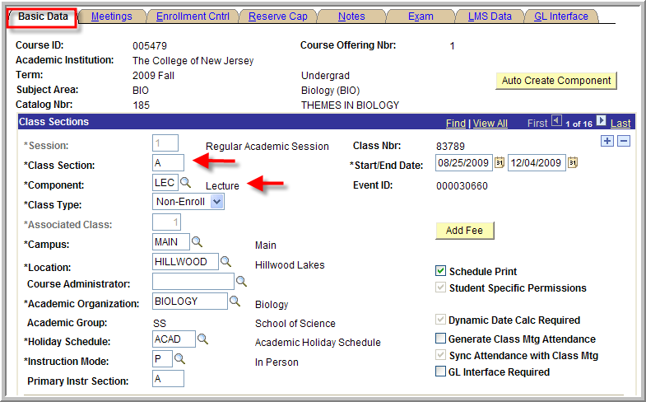

1. Click on the **Basic Data** tab on the top.
2. In order to create the lab component of the course:
   1. Click on the **“+” sign** in **Class** **Sections** to add a new row.
   2. Set the **Class Section** equal to A01 (if this is the first lab being scheduled for lecture A, otherwise, follow the sequence).
   3. Set the **Component** equal to LAB.
   4. Set **Class Type** equal to Enrollment
   5. Set **Associated Class** equal to 1 (if this is the lab being scheduled for the lecture associated with 1, otherwise, follow the sequence)
   6. Set **Campus** equal to either Main or Global.
   7. Select the **Meetings** tab on the top of the page and set up **Meeting Pattern** data (see instructions below).

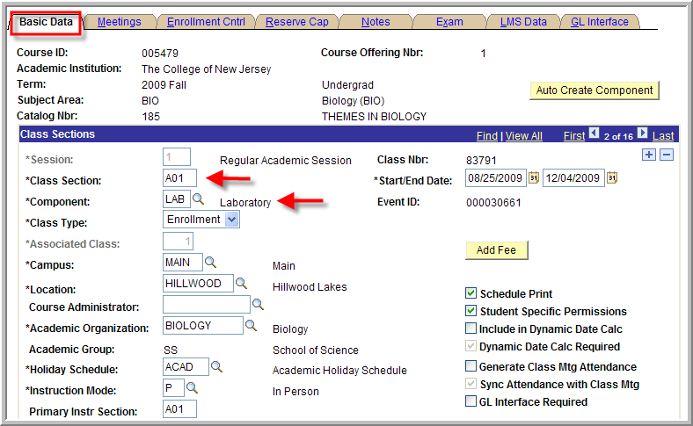

1. To set up **Meeting Pattern** and **Instructors**
   1. Click on the **Meetings** tab at the top of the page
   2. Use the magnifying glass next to **Facility ID** to select the classroom.
   3. Enter **Mtg Start** and **Mtg End** times and the days of the week.
   4. Under **Instructor for Meeting Pattern**, Use the magnifying glass next to **ID** to select the instructor.
   5. Set **Access** to Post**.**

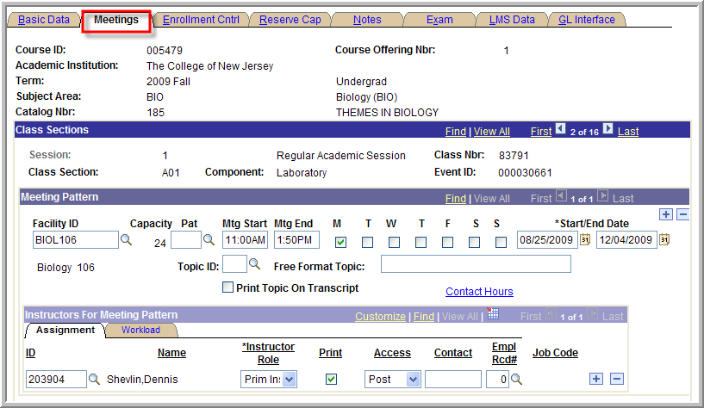

1. In order to set up the enrollment controls:
   1. Click on the **Enrollment Cntrl** tab at the top.
   2. Make sure you are looking at the lecture component (Class section A,B,C…etc).
   3. Verify the defaults.
   4. Use the arrow keys on top to navigate through the sections.
   5. For the Lab sections, Set **1st Auto Enroll Section** = A (if you are associating this lab component with section A, otherwise, enter in the appropriate section letter).
   6. Verify all other defaults.

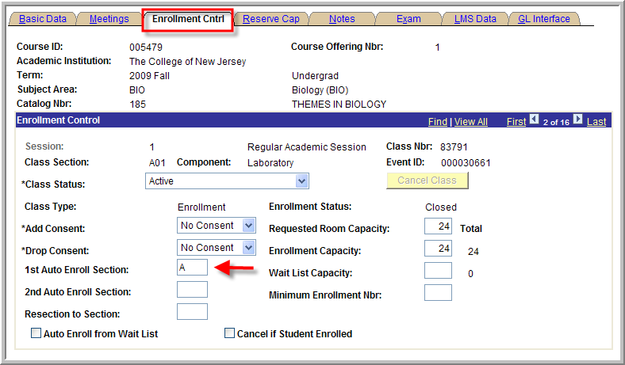

1. Click **Save.**

## How to Schedule a Lecture with Conversation Hour

When scheduling a lecture with a conversation hour component, use the following scheme for assigning section numbers: All lecture sections will be identified with a number, with the first lecture in the sequence beginning with ‘01’. Section numbers for conversation hours will always follow this sequence: C1, C2, C3, etc.

Navigation: Curriculum Management > Schedule of Classes > Schedule a New Course

(If you are making changes to a course that has already been scheduled, navigate to:  
Main Menu > Curriculum Management > Schedule of Classes > Maintain Schedule of Classes)

1. Enter in the **Term** **Code** that the class is being offered, the **Subject Area** abbreviation of the class and the **Catalog Number** and then click **search.**
2. In order to create the lecture component of the class:
   1. Under, the **Basic Data** tab, most of the values will default.
   2. Select the appropriate **Session** value for the course (most of courses are assigned to session value: 1 – Regular Academic Session).
   3. Set the **Class Section** equal to 01 (if this is the first lecture being scheduled, otherwise, follow the sequence).
   4. Set the **Component** value equal to INA (for Language Instruction).
   5. Set **Class Type** equal to Enrollment.
   6. Set **Associated Class** equal to 1 (if this is the first lecture being scheduled, otherwise, follow the sequence).
   7. Set **Campus** equal to either Main or Global
   8. Verify **Class Topic**, **Equivalent Course Group**, & **Class Attributes** are correct
   9. Click on the **Meetings** tab and enter the **Meeting Pattern** data (see instructions below).

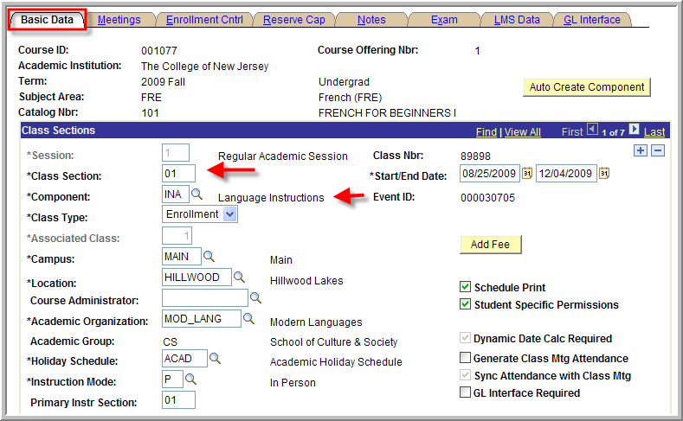

1. In order to create the conversation hour component of the class.
   1. Go back to the **Basic Data** tab and click on the “+” sign next to the **Class Sections** to create a new row.
   2. Change the **Class Section** equal to C1 (if this is the first conversation hour being scheduled, otherwise, follow the sequence. . . C2, C3, etc.)
   3. Set the **Component** equal to CHR.
   4. Set **Class Type** equal to non-enroll.
   5. Set **Associated Class** equal to 9999.
   6. Set **Campus** equal to Main or Global.
   7. Click on the **Meetings** tab and enter the **Meeting Pattern** data (see instructions below).

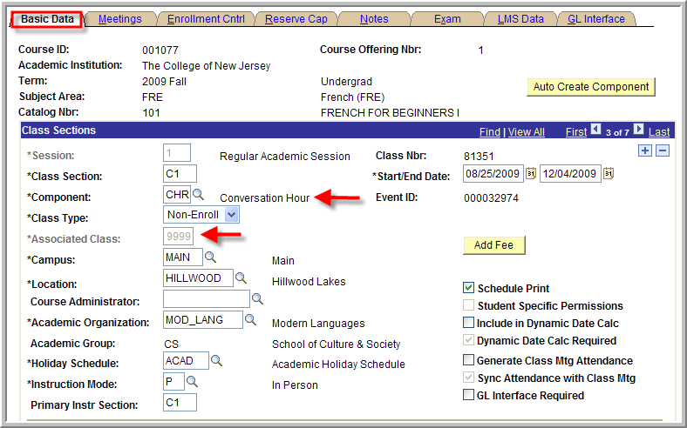

1. In order to set up the Meeting Pattern and Instructors:
   1. Use the magnifying glass next to **Facility ID** to select the classroom.
   2. Use the magnifying glass next to M**eeting Pattern** to select the meeting pattern value.
   3. Enter in the **Mtg Start** time and tab out of field to have **Mtg End** time automatically calculated.
   4. Under **Instructors for Meeting Pattern** in the **Assignment** tab, use the magnifying glass next **ID** to select the class instructor.
   5. Set **Access** to post.
   6. Under **Instructors for Meeting Pattern** click on the **Work Load** tab.
   7. Set **Assign Type** equal to Instructor
   8. Verify **Load Factor**. For 1 instructor load factor equals %100. For two instructors load factor equals 50% for each instructor. For three instructors the load factor equals 33.3 for each instructor.
   9. Verify the value in the **Workload** field is correct.
   10. Leave the **Auto Calc** box checked.
2. Click **Save**.

**How to Select a Class Topic**

Navigation: Curriculum Management > Schedule of Classes > Maintain Schedule of Classes

1. Enter the **term**, the **subject area abbreviation**, the **course number** and click **search**.
2. Under **class topic**, click the **magnifying glass** to select a **course topic ID**.

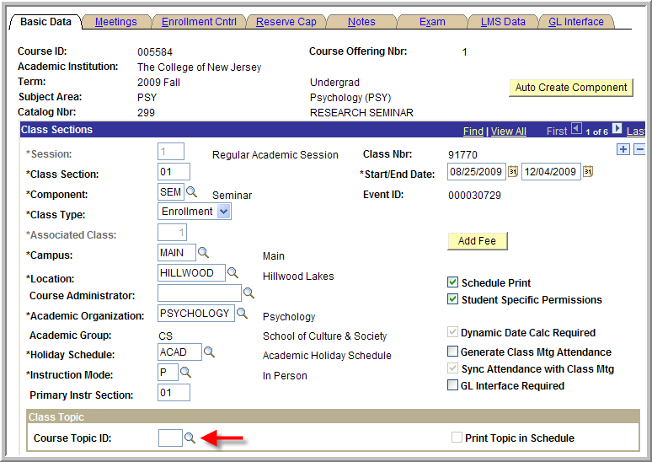

1. Select a course topic from the list provided.

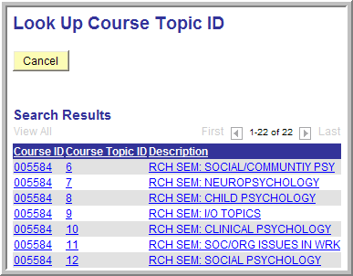

1. **Save**.

***If the topic does not appear, refer to the course catalog for the listing of all the available topics for a particular course. Email Records and Registration at [schedule@tcnj.edu](mailto:schedule@tcnj.edu) to add a topic. ***

**Adding Attributes to a Class**

Navigation: Curriculum Management > Schedule of Classes > Maintain Schedule of Classes

1. Enter in the **term** **code** that the class is being offered, the **subject area** abbreviation of the class and the **catalog number** and then click **search.**
2. Under **Basic Data,** all the way at the bottom there will be a section for **Class Attributes.** Click on the **magnifying glass** for **Course Attribute.**

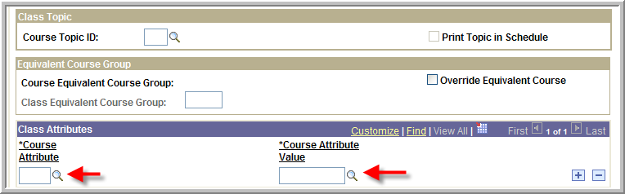

1. Search by description (change the drop down option to **contains**) or click on one from the provided list.

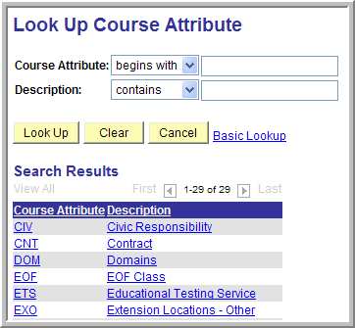

1. Once you have selected a **course attribute**, repeat the same procedure for **course attribute value**.
2. Add as many attributes as necessary by click the **“+” sign** to add a new row.
3. **Save**.

**How to Assign Zero Financial Hours to a Class**

Navigation: Curriculum Management > Schedule of Classes > Maintain Schedule of Classes

1. Enter in the **Term** **Code** that the class is being offered, the **Subject Area** abbreviation of the class and the **Catalog Number** and then click **search.**
2. Under **Basic Data,** all the way at the bottom there will be a section for **Class Attributes.** Click on the **magnifying glass** for **Course Attribute.**



1. Select **SPBL (Special Billing)** from the list provided..



1. Click on the **magnifying glass** next to **Course Attribute Value**.
2. Select **NOFINHRS (Zero Financial Hours)** from the list provided.
3. **Save**.
4. **Notify R&R** so they can set additional billing parameters.
5. **Notify Student Financial Services** which rate will be associated with this class.

**How to Add an Instructor to a Class**

Navigation: Curriculum Management > Schedule of Classes > Maintain Schedule of Classes

1. Enter in the **term** that the class is being offered, the **subject area abbreviation** of the class and the **catalog number** and then click **search.**
2. Click on the **Meetings tab** towards the top left corner.

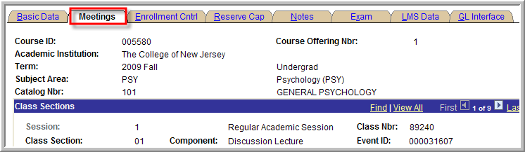

1. In the **Instructor for Meeting Pattern** bar there will be a box for ID. Click on the small **magnifying** **glass** next to this box.

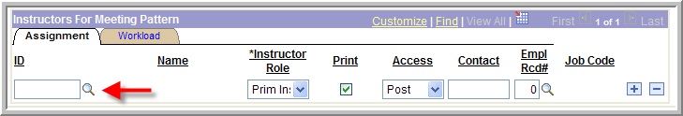

1. This will bring up the **Look Up ID screen**. Type in the last name and first initial of the instructor and select the appropriate professor from the list. If the name does not appear see the instructions below.

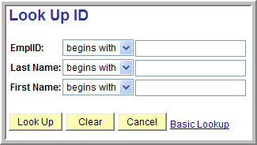

1. This will attach the instructor’s name to the class. Click on **save** and repeat for all sections/courses.
2. Make sure the Access given to the instructor is “Post”, or they will not be able to grade the class and they will not show up in SOCS.

**I. Class Facility Usage**

The Class Facility Usage page allows you to review a summary of events for a term, session, and day within a facility (building and room).

***Step One: Pulling up the Facility***

1. Log into the SA system

2. Navigate to:

*Main Menu > Curriculum Management > Facility and Event Information > Class Facility Usage*

3. Set SetID to TCNJ1; Enter any information you have and click Search. Leave fields blank for a list of all values

***Step Two: Setting Term, Session, and Days***

The facility will display with the following values defaulted in: SetID; Facility ID; Room Capacity

1. Enter in the Term, Session (optional), and Day of the Week

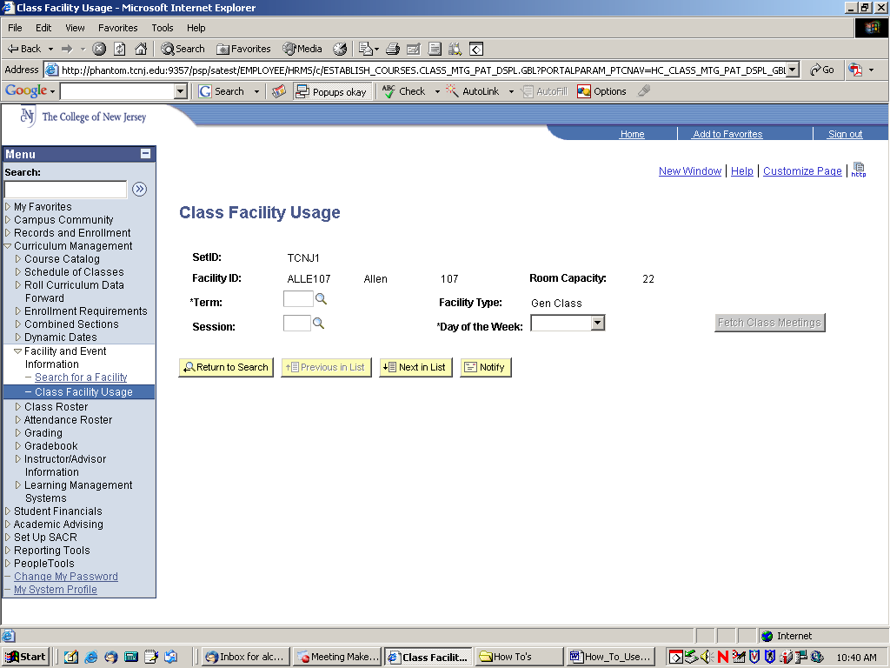

***Step Three: Fetch Class Meetings***

1. Select the Fetch Class Meetings button to retrieve and review the results

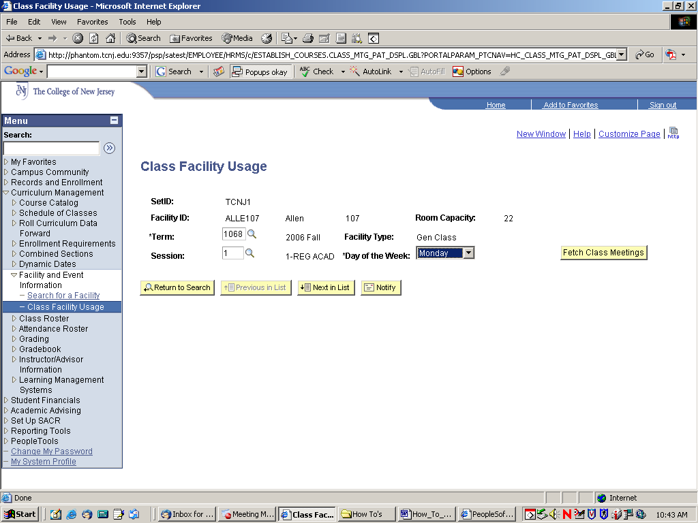

**Finding a Room for Classes or Exams**

Navigation: Curriculum Management > Schedule of Classes > Maintain Schedule of Classes

1. Enter in the **term** **code** that the class is being offered, the **subject area** abbreviation of the class and the **catalog number** and then click **search.**
2. Select the **Meetings** or **Exam** tab.

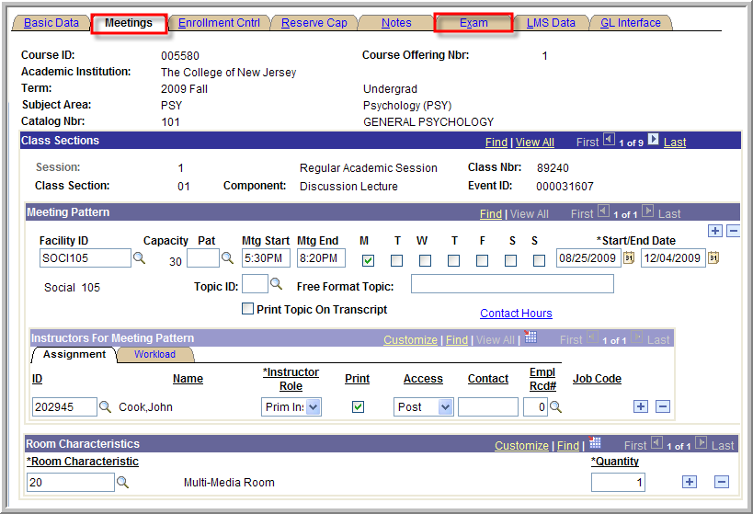

1. Review the existing meeting information. Enter new meeting information or an exam time code, if necessary.
2. Open a new window in PAWS.
3. Navigation: Curriculum Management > Facility and Event Information > Search for a Facility
4. Click **Search.**
5. Enter the meeting pattern or exam date and time information, select a building if you want and click on **Fetch Facilities**.

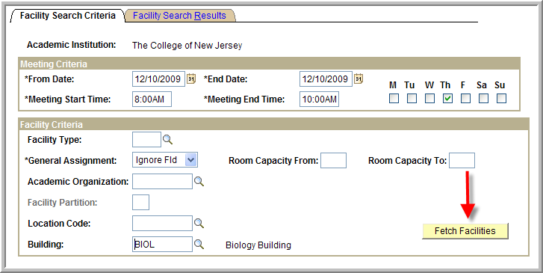

1. This will produce a list of results.

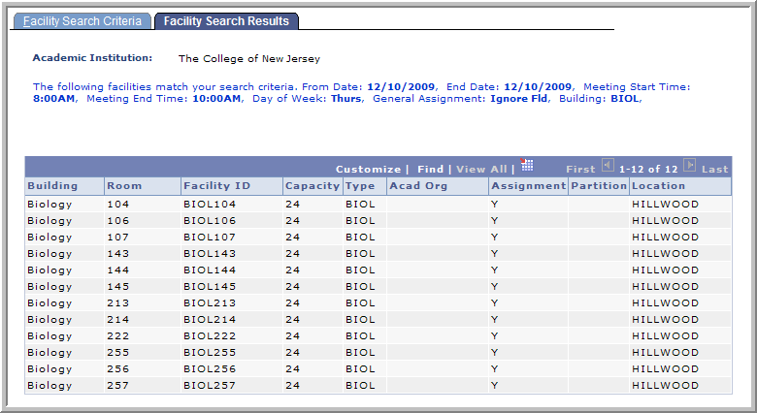

1. Pick a room.
2. Return to the first window, **Maintain Schedule of Classes**, and enter the room in the **Meetings** or **Exam** tab.
3. **Save**.

**How to Combine Classes**

**Definition of Combined Classes**

When one or more classes meet together in the same room at the same days and times, with the same instructor, they are combined classes. Generally these classes meet the same academic requirement but are offered under different academic disciplines.

Students enroll in accord with their requirements

**Preparation for Scheduling Combined Classes**

Discuss your plan to combine your class with the Chair of the partner department. Both departments need to agree to offer the classes as combined, as well as on the following schedule details:

* 1. Session
  2. Meeting days
  3. Start time
  4. End time
  5. Room request or room features needs
  6. Instructor
  7. Total enrollment cap and each section’s starting share of the total cap

Each department then schedules its combined class in SA. Basic steps are as follows:

Navigation: Curriculum Management > Schedule of Classes > Schedule a New Course

(If you are making changes to a course that has already been scheduled, navigate to:

Main Menu > Curriculum Management > Schedule of Classes > Maintain Schedule of Classes)

1. Enter in the **Term** **Code** that the class is being offered, the **Subject Area** abbreviation of the class and the **Catalog Number** and then click **search.**
2. Under the **Basic Data** tab, most of the values will default.
   1. Select the appropriate **Session** value for this course (most courses are assigned value 1- Regular Academic Session).
   2. Change the **Class Section** equal to 01 (if this is the first lecture being scheduled, otherwise, follow the sequence).
   3. Set the **Component** equal to the appropriate lecture/seminar activity code associated with the course (LDI for Discussion Lecture, LEC for Lecture or SEM for Seminar).
   4. Set **Class Type** to Enrollment.
   5. Set **Associated Class** equal to 1 (if this is the first lecture being scheduled, otherwise, follow the sequence).
   6. Set **Campus** equal to either Main or Global.
   7. Verify **Class Topic**, **Equivalent Course Group**, & **Class Attributes** are correct.



Both Departments schedule the same up to this point.

The next step, establishing the meeting pattern, is done by one Department or the other taking the lead. Conflict checking in PAWS will not allow both Departments to fully schedule the same room for the same time for two different classes, even though they will be combined in a later step by R&R. Data entered for the meeting pattern data by one Department in their class, will be copied to any other class when combined by R&R.

1. One Department will click on the **Meetings** tab at the top.
   1. Use the magnifying glass next to **Facility ID** to select the classroom.
   2. Use the magnifying glass next to M**eeting Pattern** to select the meeting pattern value.
   3. Enter in the **Mtg Start** time and tab out of field to have **Mtg End** time automatically calculated.
   4. Under **Instructors for Meeting Pattern** in the **Assignment** tab, use the magnifying glass next **ID** to select the class instructor.
   5. Set **Access** to post.



* 1. Under **Instructors for Meeting Pattern** click on the **Work Load** tab.
  2. Set **Assign Type** equal to Instructor
  3. Verify **Load Factor**. For 1 instructor load factor equals %100. For two instructors load factor equals 50% for each instructor. For three instructors the load factor equals 33.3 for each instructor.
  4. Verify the value in the **Workload** field is correct.
  5. Leave the **Auto Calc** box checked.



1. Click **Save**.
2. To add another lecture section, navigate back to the **Basic Data** tab and click on the **“+ sign”** under the **Class Section** heading. This will create a new row and you will need to repeat steps 1 through 4 again.
3. Notify R&R that the classes will be combined. R&R will take care of that step.
4. Any subsequent meeting pattern changes can be done by either Department by using the menu option ‘Schedule Class Meetings’ [rather than ‘Maintain Schedule of Classes’]. A change in the meeting pattern here for one class will also update the meeting pattern information for any combined classes.

**How to Reserve Seats in a Class for a Specific Student Population**

Navigation: Curriculum Management > Schedule of Classes > Maintain Schedule of Classes

1. Enter in the **Term** **Code** that the class is being offered, the **Subject Area** abbreviation of the class and the **Catalog Number** and then click **search.**
2. Click on the **Reserve Cap** tab. (Verify that you are on the appropriate class component and section).

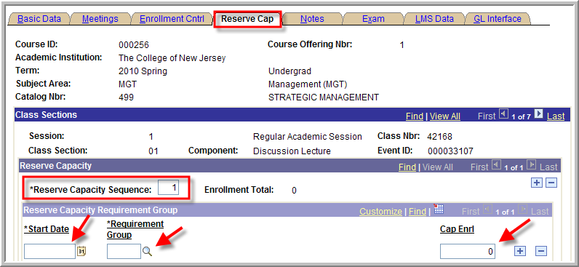

1. Enter “1” for **Reserve Capacity Sequence**.
2. Enter the **Start Date**.
3. Click the **magnifying glass** next to **Requirement Group.**
4. Search by description (change the drop down menu to contains).

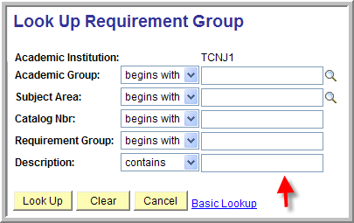

1. Enter the appropriate number for **Cap Enrl.**
2. **Save**.

**How to Release Reserved Seats in a Course**

Navigation: Curriculum Management > Schedule of Classes > Maintain Schedule of Classes

1. Enter in the **Term** **Code** that the class is being offered, the **Subject Area** abbreviation of the class and the **Catalog Number** and then click **search.**
2. Click on the **Reserve Cap** tab. (Verify that you are on the appropriate class component and section).



1. Enter “1” for **Reserve Capacity Sequence**.
2. Click the **“+” sign** next to **Cap Enrl**, this will create a new row.
3. Enter the appropriate **Start Date** on which you would like to release the reserved seats to the general student population.
4. Click on the **magnifying glass** next to **Requirement Group**.
5. Search by description (change the drop down menu to contains) for the group that the seats are currently being reserved for.



1. Set **Cap Enrl** equal to **0.**
2. **Save**.

**How to Delete a Class Section**

**NOTE:** Class sections should only be deleted during the preliminary schedule planning process. Once the class schedule is opened to the students to view and/or pre-register, a class should be ‘Cancelled’ rather than deleted if it is determined that the class will not be held for the given term.

Navigation: Curriculum Management > Schedule of Classes > Maintain Schedule of Classes

1. Enter the **term**, **subject area** abbreviation and the **catalog number** and then click **search**
2. In order to delete a class section click on the **“-“ sign**.
3. When you press the **“-“ sign** the system will display the following message: “*Delete Current/Selected Rows from this Page? The delete will occur when the transaction is saved.”* Press OK.

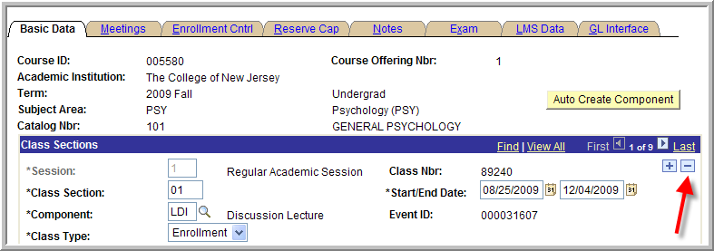

1. **Save**.

## How to Remove a Class Section

**NOTE:** Class sections should only be deleted during the preliminary schedule planning process. Once the class schedule is opened to the students to view and/or pre-register, a class should be ‘Cancelled’ rather than deleted if it is determined that the class will not be held for the given term.

Navigation: Curriculum Management > Class Schedule > Maintain Schedule of Classes

1. Enter in the **Term** **Code** that the class is being offered, the **Subject Area** abbreviation of the class and the **Catalog Number** and then click **search.**
2. Use the left and right arrows in the **Class Section** section to select the appropriate class section.
3. Click the **“-“ sign** to delete the class section.

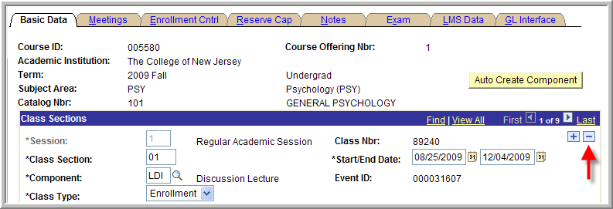

1. The system will display the following message: “Delete Current/Selected Rows from this Page? The delete will occur when the transaction is saved.” Click **OK**.
2. **Save**.

## How to Print the Class Schedule

Navigation: Curriculum Management > Schedule of Classes > Print Class Schedule

1. Add a run control by selecting the **Add a New Value** tab. Type your **Student Administration User ID** into the **Run Control ID Field** and press the **Add** button. **Please Note:**  If you have already created a run control id for this process, search for and select the value from the **Find an Existing Value** tab.

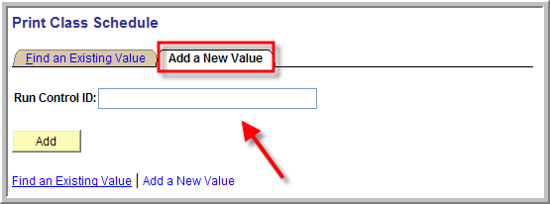

1. Enter in **TCNJ1** for the **Academic Institution,** enter in the **Term** code, using the [Look up Academic Organization Node (Alt+5)](javascript:submitAction_win0(document.win0,'RUN_CNTL_SR_ACAD_ORG$prompt');) select your department value for **Academic Organization Node** field value (to print the complete schedule of classes select the value of **TCNJ1**). Enter in a **Session** value.
2. **Schedule Print** and **Print Instructor in Schedule** will default to Yes. You can change these selections
3. **Class Status of Active** and **Stop Enrl** will default in checked. You can change these selections.

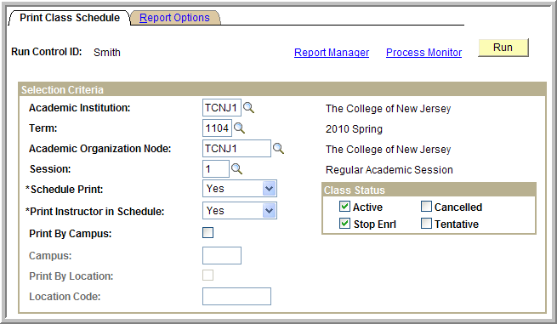

1. Select the **Report Options** tab.

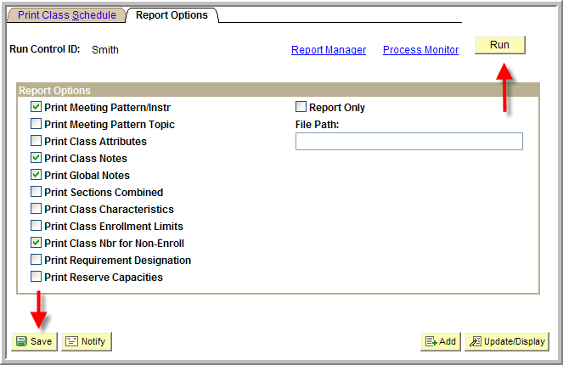

1. Select the desired report options.
2. Click **Save** to save your selection criteria and report options. The next time you print the Class Schedule, these selections will default in.
3. Click the **Run** button on the upper right part of screen.
4. The **Process Scheduler Request** screen will display.

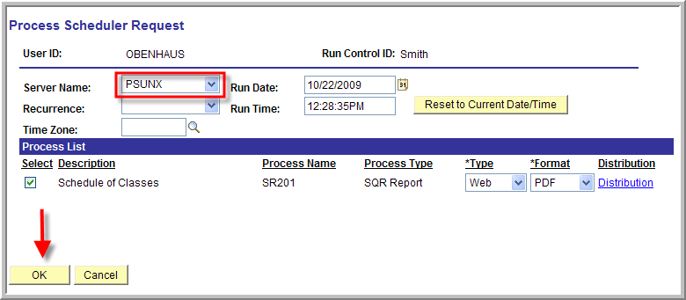

1. Select **PSUNX** for the **Server Name**.
2. Select OK to process the report.
3. This will bring you back to the **Print Class Schedule** page.
4. On the Print Class Schedule pages, select the link **Report Manager** (upper right of screen).
5. The Report Manager screen will display. Select the **Administration** tab.
6. If your report status displays N/A, the report is still processing. Give it another minute or two and then select the Refresh button to refresh the status. If your report status displays Posted, the report is done processing and ready to be viewed and printed!
7. Select the report by clicking on the highlighted description, the report will open in Adobe Acrobat format.

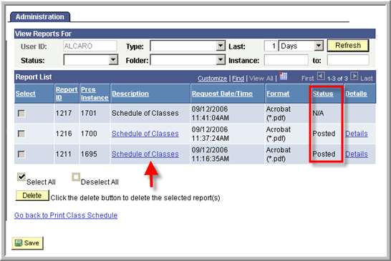

1. To return to the **Print Class Schedule** page, select the link **Go back to Print Class Schedule**.

Alternatively, use the PAWS queries listed at the beginning of the Chairs training document.

MCj04136380000[1]1.1 Setting up Student Specific Permissions

Lesson Objective: Student-specific permissions enable instructors or administrators to control section enrollment by granting advance add permission to individual students. This lesson teaches you how to set this up on the class

1. Navigate to:   
   **Curriculum Management > Schedule of Classes > Maintain Schedule of Classes**
   1. Note: The above navigation is for modifying an existing class. To schedule a new course, navigate to Curriculum Management > Schedule of Classes > Schedule New Course
2. Enter in Term, Subject, and Catalog number of class you wish to modify
   1. Need more help at this step? See the ‘How to Schedule a Class’ help document.
3. Verify the Student Specific Permissions box is selected: See picture below

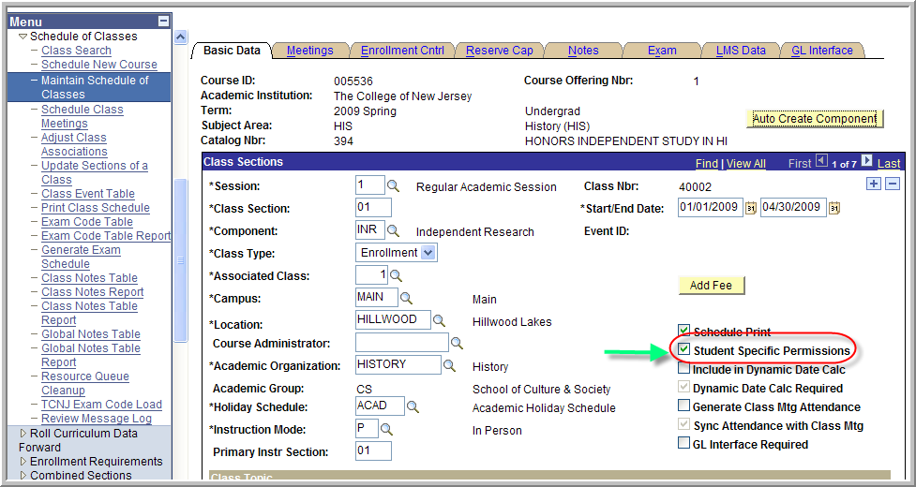

1. Select tab: Enrollment Cntrl
   1. Under ‘Add Consent’, select Dept Cnsnt. Save your changes.
      1. Note: There is also an option for Drop Consent. By setting Drop Consent, you are stopping students from dropping the class unless they have permission.

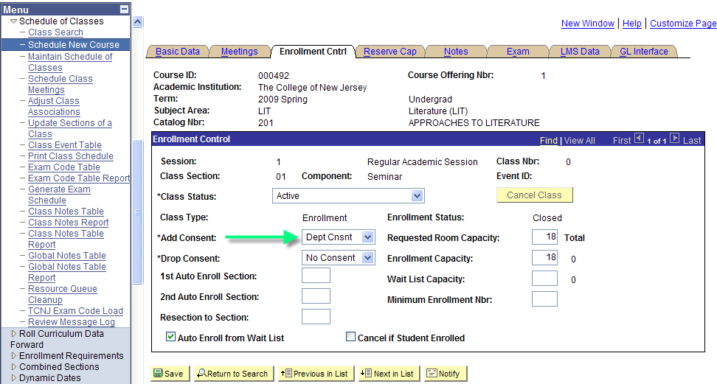

C:\Documents and Settings\alcaro\Local Settings\Temporary Internet Files\Content.IE5\1TV8GE3J\MCj04136180000[1].wmf

This is what appears to the student:

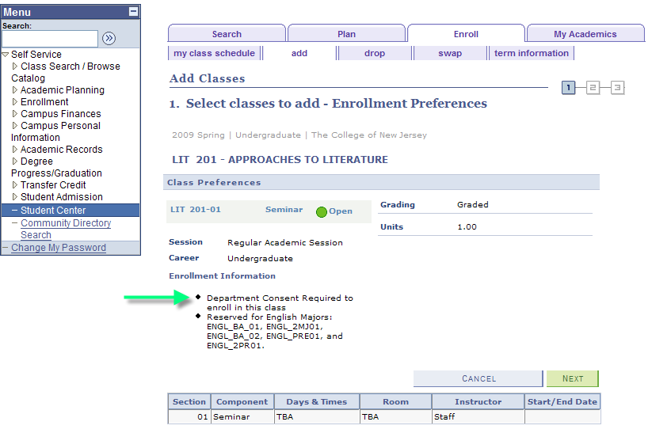

If the Student does not have permission, she is unable to add the class:

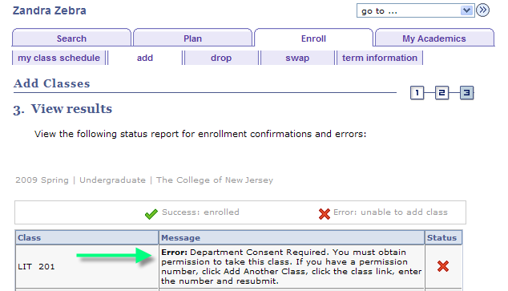

**1.2 Granting a Student Permission: OPTION 1 (used prior to student registering)**

Lesson Objective: In this lesson, we are granting a student permission to enroll in the class prior to their enrollment appointment time. This enables the student to register in the class through self-service when their enrollment appoint time begins.

1. Navigate to:   
   **Records and Enrollment > Term Processing > Class Permissions > Class Permission Numbers**
2. Enter in Term, Subject, and Catalog number of class you need to add the student permission
3. Under area ‘Permission Valid For:” select the box ‘Consent Required’. Verify this is the only option selected (see picture below).
4. Under area ‘Class Permission Data’ Add the student’s EMPL ID. If adding more than one student, select the  to add a row and continue to enter in student EMPL ID numbers.
5. Select Save when finished.

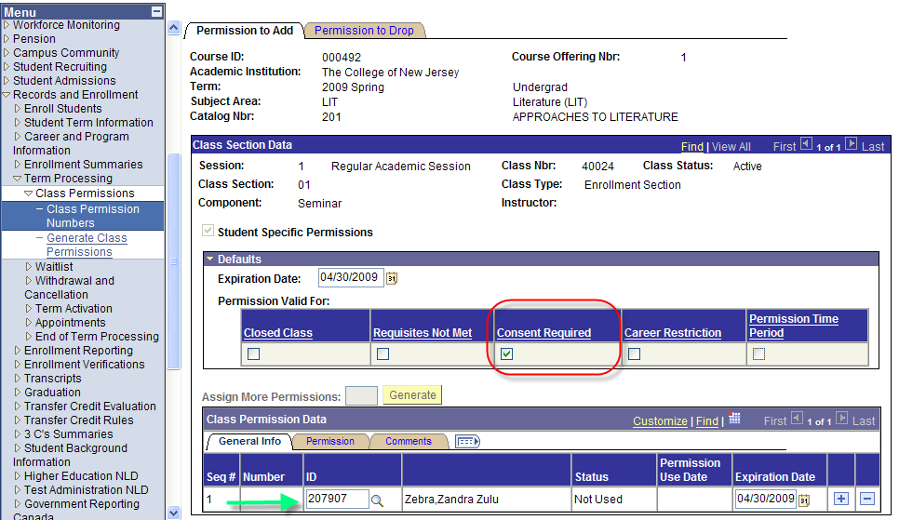

**1.3 Granting a Student Permission: OPTION 2 (used to register student)**

Lesson Objective: In this lesson, we are overriding the permission and enrolling the student into the class.

1. Navigate to:   
   **Records and Enrollment > Enroll Students > Quick Enroll A Student**
2. Enter in EMPL ID, Career, Institution and Term (see picture below)

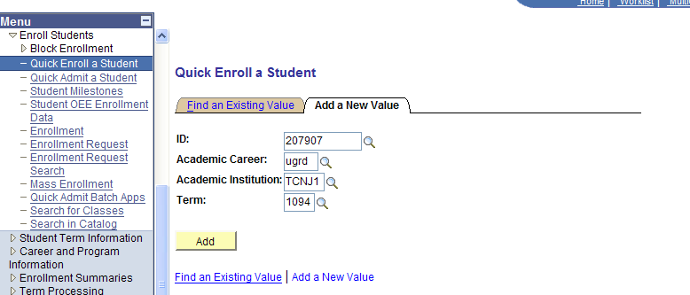

1. The default Action is ‘Enroll’. Leave at ‘Enroll’, and enter in the Class Nbr. (see picture below)

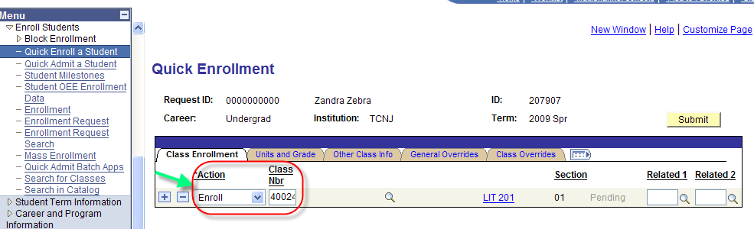

1. Select the tab: Class Overrides
2. Check off ‘Class Permission’ (see picture below)

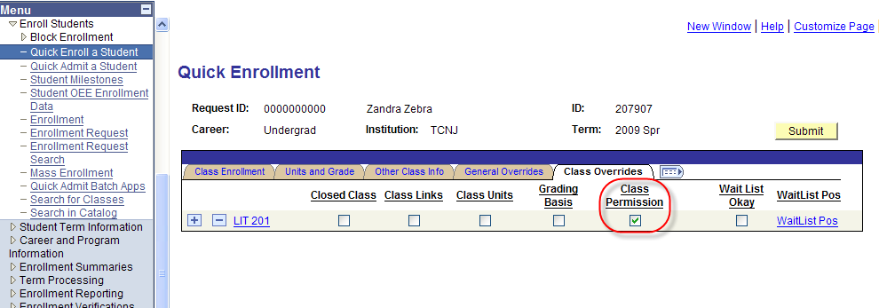

1. Select the Submit button. Student is registered for the class.
   1. Note the ‘Success’ message appears

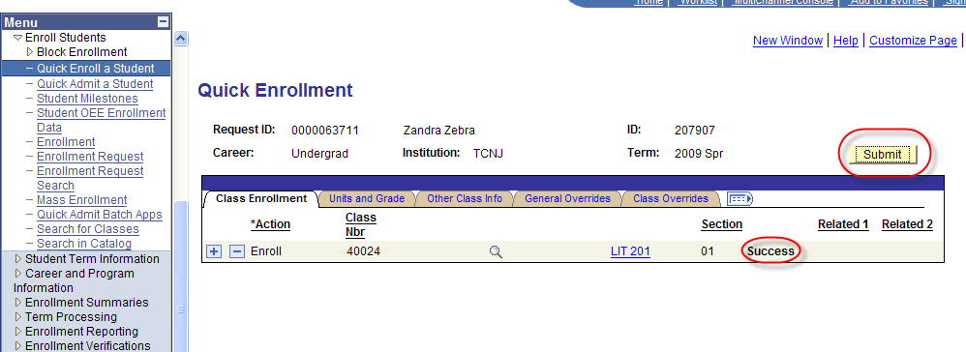

MCj04136380000[1]2.1 Schedule Print

Lesson Objective: The ‘Schedule Print’ box on the Basics Data tab of a Class allows you to control whether you would like the class displayed in the Class Search. For example, you may not want an Independent Study displayed to students in the Class Search. This lesson teaches you how to set this up on the class.

1. Navigate to:   
   **Curriculum Management > Schedule of Classes > Maintain Schedule of Classes**
   1. Note: The above navigation is for modifying an existing class. To schedule a new course, navigate to Curriculum Management > Schedule of Classes > Schedule New Course
2. Enter in Term, Subject, and Catalog number of class you wish to modify
   1. Need more help at this step? See the ‘How to Schedule a Class’ help document.
3. By default, Schedule Print is checked off. Select ‘Schedule Print’ to remove the checkbox. Save the class.
   1. See picture below

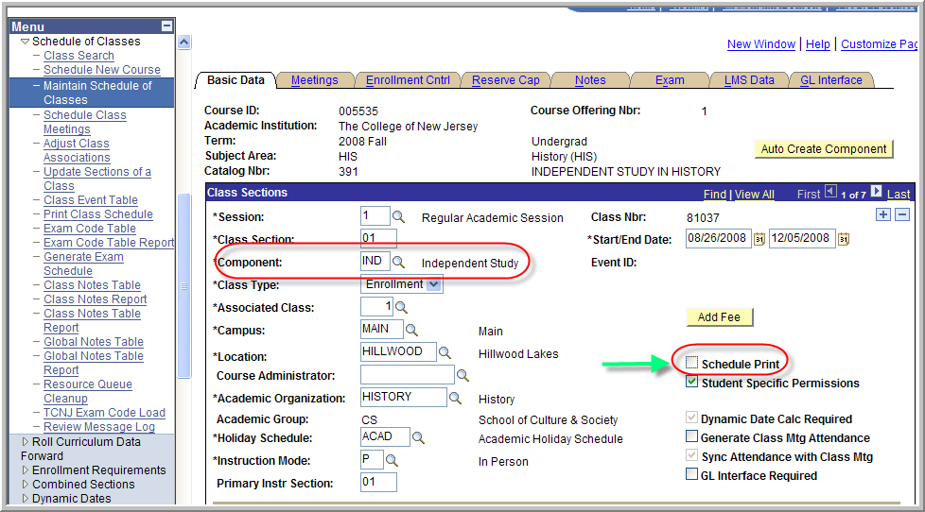

MCj04136380000[1]3.1 Meeting Pattern, Instructors and Workload

Lesson Objective: Review the data in Meeting Pattern and Instructors, add a Proxy instructor and review workload

1. Navigate to:   
   **Curriculum Management > Schedule of Classes > Maintain Schedule of Classes**
   1. Note: The above navigation is for modifying an existing class. To schedule a new course, navigate to Curriculum Management > Schedule of Classes > Schedule New Course
2. Enter in Term, Subject, and Catalog number of class you wish to modify
   1. Need more help at this step? See the ‘How to Schedule a Class’ help document.
3. Select the tab: Meetings

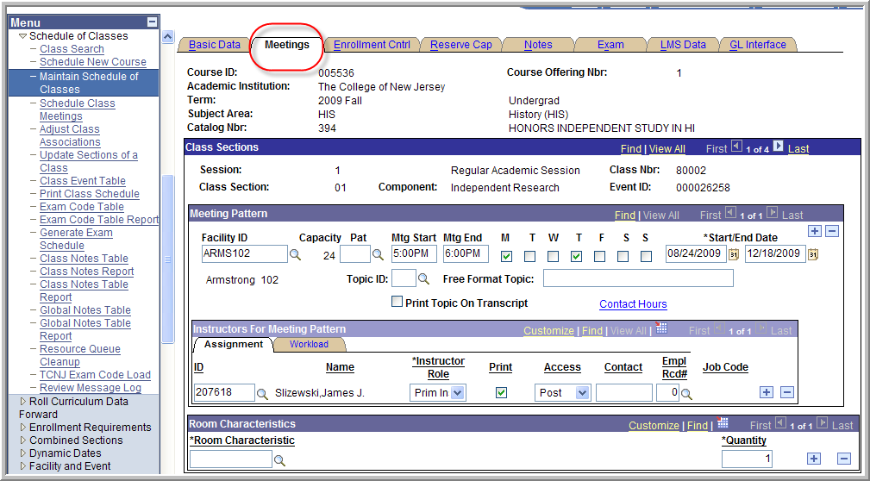

Meeting Pattern Tips:

1. Facility ID: Instead of using the magnifying glass to look up the Facility ID, try typing it in by learning the 4 letter code for the building, followed by the room number.

Example: Armstrong Hall = ARMS Bliss Hall = BLIS Social Science = SOCI

1. Verify the Capacity is accurate (displayed next to the Facility ID)
2. Use a Pattern code for easy data entry.
3. Do not use the Topic ID or Free Format Topic under Meeting Pattern

**3.2 Setting Instructor Access to Post**

Lesson Objective: In order for an instructor to grade a class, the Access must be set to ‘Post’

1. Navigate to:   
   **Curriculum Management > Schedule of Classes > Maintain Schedule of Classes**
   1. Note: The above navigation is for modifying an existing class. To schedule a new course, navigate to Curriculum Management > Schedule of Classes > Schedule New Course
2. Enter in Term, Subject, and Catalog number of class you wish to modify
   1. Need more help at this step? See the ‘How to Schedule a Class’ help document.
3. Select the tab: Meetings
4. Verify Access is set to Post. Select Save

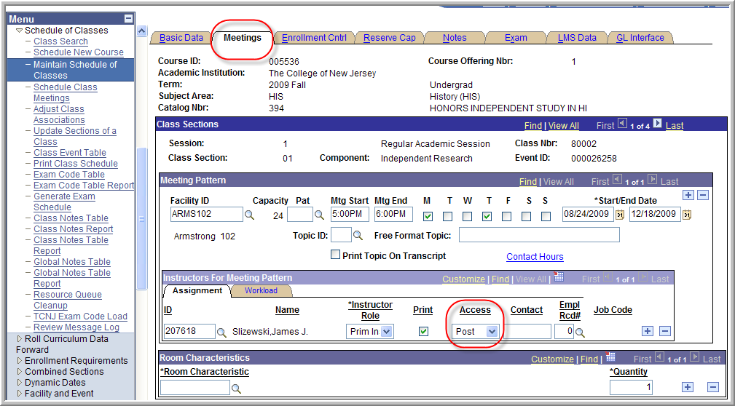

**3.2 Adding Proxy to Grade**

Lesson Objective: In the event a class will be graded by someone other than the Instructor, add the person to the ‘Instructors for Meeting Pattern’ page and set access to ‘Post’.

1. Navigate to:   
   **Curriculum Management > Schedule of Classes > Maintain Schedule of Classes**
2. Enter in Term, Subject, and Catalog number of class you wish to modify
3. Select the tab: Meetings
4. Under the Assignment tab, select the select the  to add a row. Enter in the Proxy’s EMPL ID.
5. Deselect ‘Print’ so that it does not display in schedule of classes (see picture below)
6. Select Access to ‘Post’

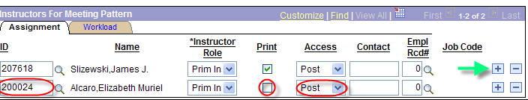

1. Next, select the Workload tab (see picture below)
2. Select Assign Type and change to ‘Not Incl’ so that workload is not calculated for the Proxy (see picture below). Deselect Auto Calc, Remove Work Load and Load Factor
3. When you are finished, select Save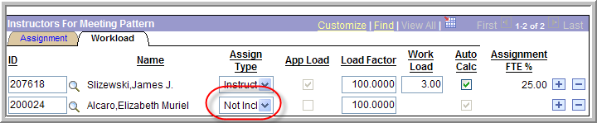

**3.3 Reviewing Workload**

Lesson Objective: It is a good idea to review workload prior to the schedule being published. It could potentially catch any errors and helps make IR reporting much cleaner.

1. Navigate to:   
   **Curriculum Management > Schedule of Classes > Maintain Schedule of Classes**
2. Enter in Term, Subject, and Catalog number of class you wish to modify
3. Select the tab: Meetings
4. Under the Instructors for Meeting Pattern section, select the Workload tab.
5. Load Factor and Work Load are displayed. Auto Calc should be selected and should not be changed.

**3.4 Reviewing Instructor Schedule**

1. Navigate to: Curriculum Management > Instructor/Advisor Information > Instructor Schedule

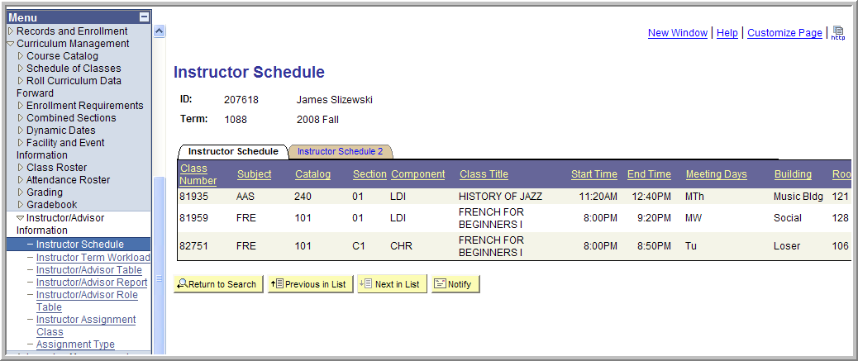

**3.5 Reviewing Term Workload**

1. Navigate to: Curriculum Management >Instructor/Advisor Information > Instructor Term Workload

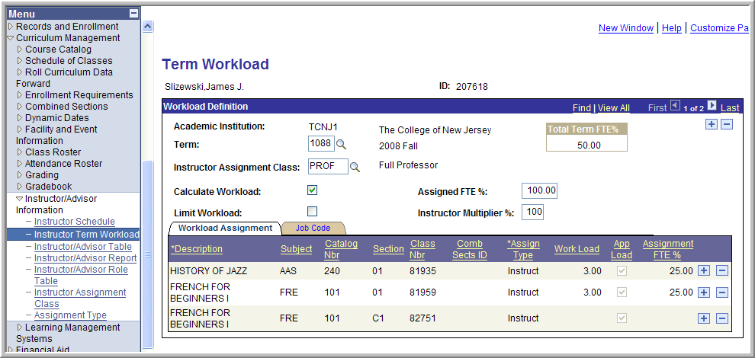

MCj04136380000[1]4.1 Changing Class Status

Lesson Objective:

1. Navigate to:   
   **Curriculum Management > Schedule of Classes > Maintain Schedule of Classes**
   1. Note: The above navigation is for modifying an existing class. To schedule a new course, navigate to Curriculum Management > Schedule of Classes > Schedule New Course
2. Enter in Term, Subject, and Catalog number of class you wish to modify
   1. Need more help at this step? See the ‘How to Schedule a Class’ help document.
3. Select the tab: Enrollment Cntrl
4. Under Class Status, the default is Active

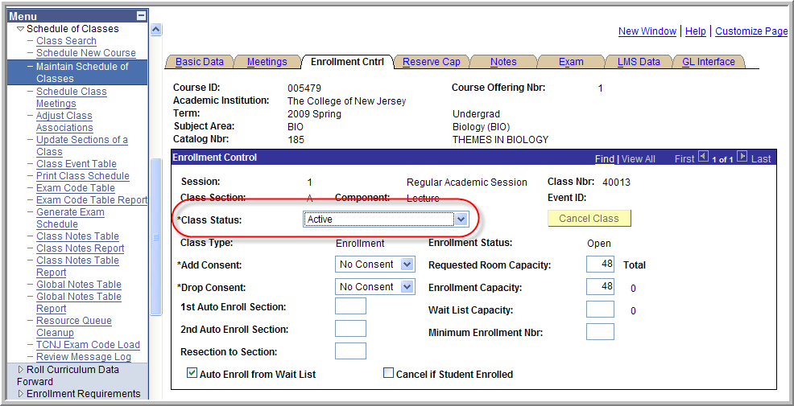

**4.2 To Cancel a Class without Enrollments**

1. From Class Status, Select ‘Cancelled Section’. Note that the ‘Cancel Class’ button highlights (see picture below)
2. Select the ‘Cancel Class’ button and Save

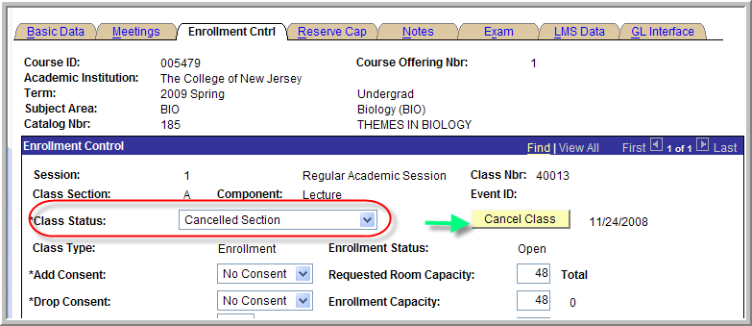

1. The Enrollment Status changes to Closed. The class is no longer in the Class Search, however cancelling a class does not remove the class from the term. Notice that the class still has a Class Nbr. This is not the same a deleting a class.

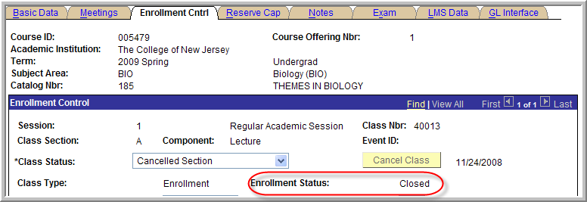

**4.3 To Cancel a Class with Enrollments**

1. Select ‘Cancel if Student Enrollment’ box
2. From Class Status, Select ‘Cancelled Section’. Note that the ‘Cancel Class’ button highlights (see picture below)
3. Select the ‘Cancel Class’ button and Save
4. Open a new window and print a class roster. [This is necessary until workflow processes are established.]
5. Students are removed from the class and [when workflow is established] an email is generated to the Instructor and the Student that the class was cancelled. In the meantime, an email must be sent to the students advising them that the class has been cancelled.

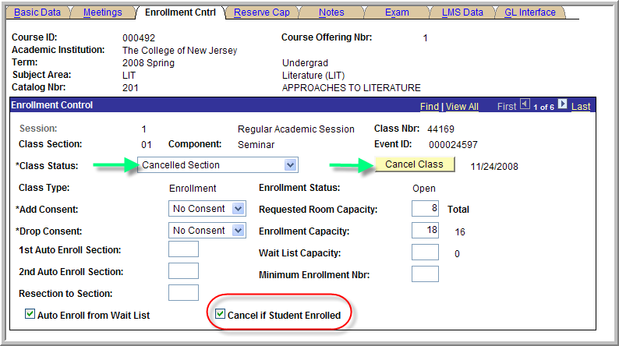

**4.4 To Stop Students from Continuing to Enroll**

1. From Class Status, Select ‘Stop Further Enrollment’.
2. Select Save
3. The Enrollment Status changes to Closed.

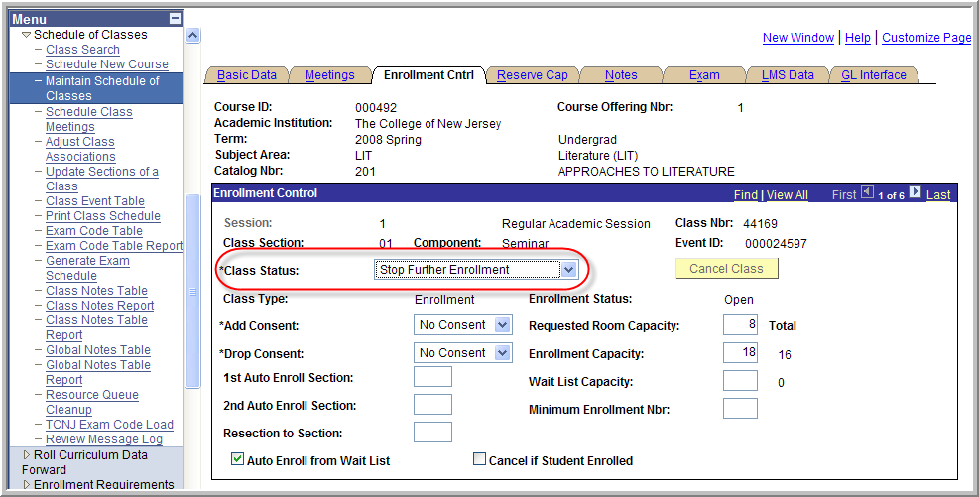

MCj04136380000[1]5.1 Reserve Capacity (AKA Seatholds)

Lesson Objective: Learn how to add and manage reserve capacity in SA. All Requirement Groups that should be applied as a seathold begin with the description designation of SH. If you need a new Requirement Group created, contact the Scheduling Office. You can define any number of reserve capacity groups for a class. When a student enrollment request is processed, the system automatically searches through the reserve capacities in sequential order and places the student in the first group with an available spot for which the student qualifies based on the reserve capacity group rules. You can only put Reserve Cap’s on the Enrollment section. Reserve caps can be set up to expire in the future. They do not appear in the online schedule of classes.

1. Navigate to:   
   **Curriculum Management > Schedule of Classes > Maintain Schedule of Classes**
   1. Note: The above navigation is for modifying an existing class. To schedule a new course, navigate to Curriculum Management > Schedule of Classes > Schedule New Course
2. Enter in Term, Subject, and Catalog number of class you wish to modify
   1. Need more help at this step? See the ‘How to Schedule a Class’ help document.
3. Select the tab: Reserve Cap
4. Reserve Capacity is controlled by Sequence #’s and by Start Dates. Each Reserve Capacity Sequence number must use one and only one Requirement Group. The system will not allow the use of more than one Requirement Group with the same start date. Use of separate Requirement Groups on different dates, will put a different requirement in effect depending upon the dates. If two different requirement groups are desired, they must be in two separate sequences.

Enter in a Start Date and the Requirement Group. Select Save

Take a look at the example below. The class AFA 311 has 16 seats. In this example, all 16 seats are being reserved for Fine Arts majors. The Start Date of 03/31/2009 indicates that as of the first day of registration, the reserve capacity is in effect

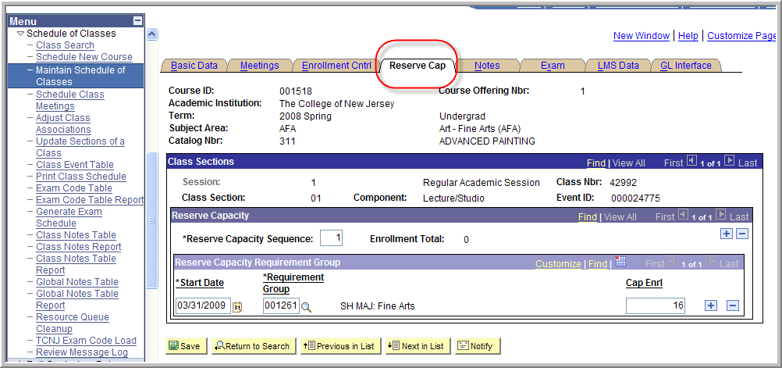

**5.2 Adjusting the enrollment cap for one requirement group**

Using the example above, let’s say it is the second week of registration and you are concerned because only 5 Fine Arts majors have enrolled into the class. You would now like to lower the cap for the Fine Arts major from 16 to 12. This will allow 4 non Fine Arts students to enroll.

1. Add a new row at the requirement group level by selecting the 
2. Enter in a new Start Date and the Requirement Group. The Start Date is the date the enforcement of the Reserve Cap is to begin.
3. Change the Cap Enrl. The Cap Enrl is the maximum number of students that can be enrolled for a particular class section. This number cannot exceed the total enrollment capacity for a particular class section.

Remember the Total Class Capacity = 16  
  
From 3/31/2009 – 04/06/2009:   
All 16 seats were held for Fine Arts majors  
 - 5 Fine Arts majors enrolled  
 11 seats left  
  
From 04/07/2009 - onward:  
  
The possibilities for the 11 remaining seats are….

Fine Art Student Non Fine Art Student  
11 0

10 1

9 2

8 3

7 4

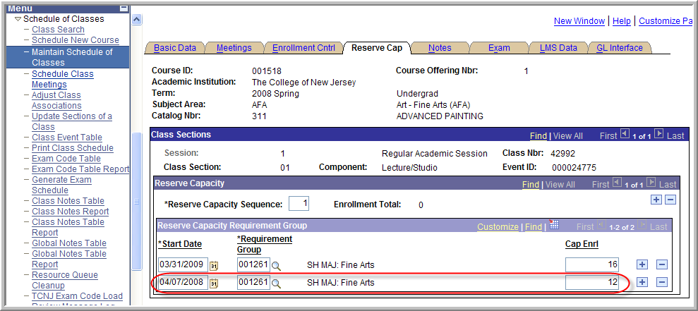

**5.3 Adding multiple Requirement Groups by adding a new Sequence**

1. Add a new row at the sequence level by selecting the 
   1. Note: Select ‘View All’ to display the entire sequence
2. Enter in a new Start Date and the Requirement Group for Sequence #2.
3. Enter in the Cap Enrl

In the example below, HIS 220 01 has a capacity of 25. A sequence of reserve capacities is scheduled so that also beginning 04/01/2009 10 seats are reserved for Pre-history students and also beginning 04/01/2009, 15 seats are reserved for History Education majors.

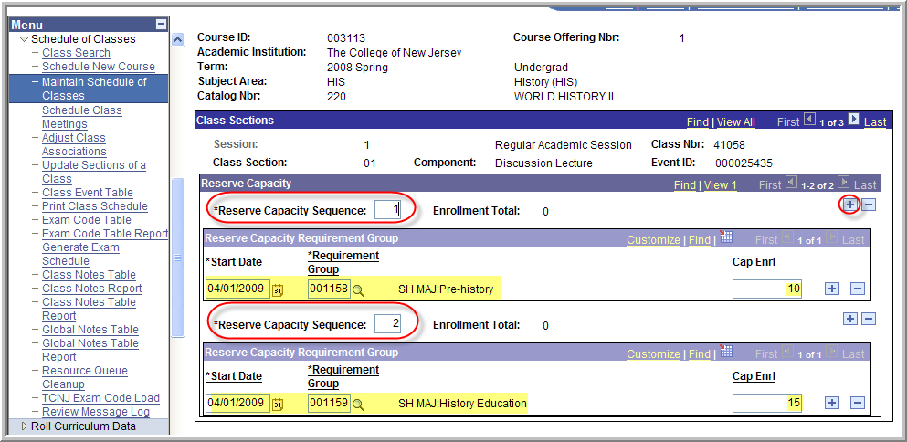

**5.4 Creating Reserve Capacity that will Expire in the Future:**

1. Add a new row at the requirement group level by selecting the 
2. Enter in a new Start Date and the Requirement Group for Sequence #2.
3. Enter in the Cap Enrl of 0

In the example below, HIS 220 01 has a capacity of 25. A reserve capacity is scheduled so that from 06/22/2009 to 07/02/2009 all 25 seats are reserved for freshmen.

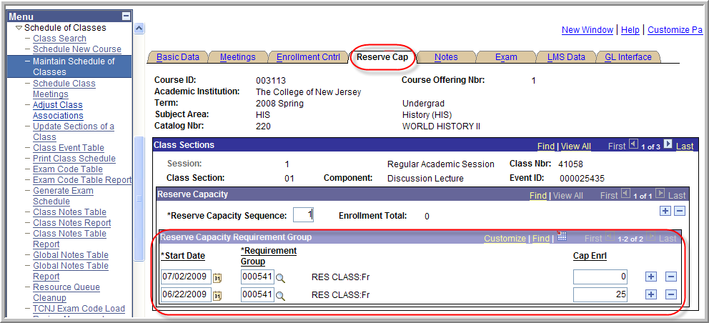

**5.5 Reserve Capacity Special Notes**

1. After you have setup the reserve caps and students begin enrolling in the class, the Enrollment Total for each reserve capacity sequence line on the page will increment whenever students enroll who fit any of these categories.

2. Once a student is enrolled in the class, you cannot delve reserve capacities. You can change existing reserve capacities and add new ones.

3. Reserve Caps can be rolled with the term roll.

MCj04136380000[1]6.1 Class Notes

Lesson Objective: Learn how to add Free Format Text as well as use Note Numbers.

1. Navigate to:   
   **Curriculum Management > Schedule of Classes > Maintain Schedule of Classes**
   1. Note: The above navigation is for modifying an existing class. To schedule a new course, navigate to Curriculum Management > Schedule of Classes > Schedule New Course
2. Enter in Term, Subject, and Catalog number of class you wish to modify
   1. Need more help at this step? See the ‘How to Schedule a Class’ help document.
3. Select the tab: Notes
4. Type in a note in the Free Format Text area. ***This note displays in the Class Search***.

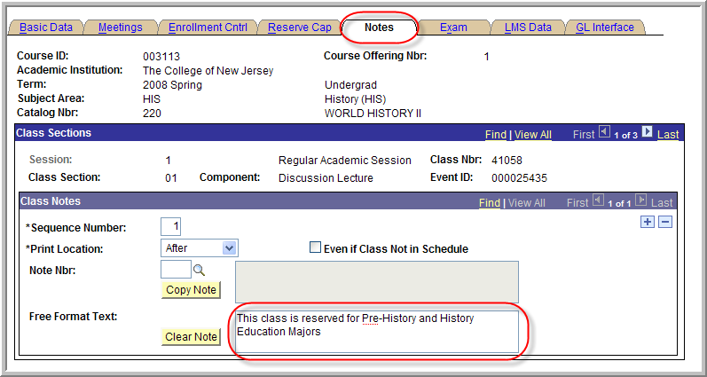

C:\Documents and Settings\alcaro\Local Settings\Temporary Internet Files\Content.IE5\1TV8GE3J\MCj04136180000[1].wmf

This how the Class Note appears in the Schedule of Classes when the students selects the section link:

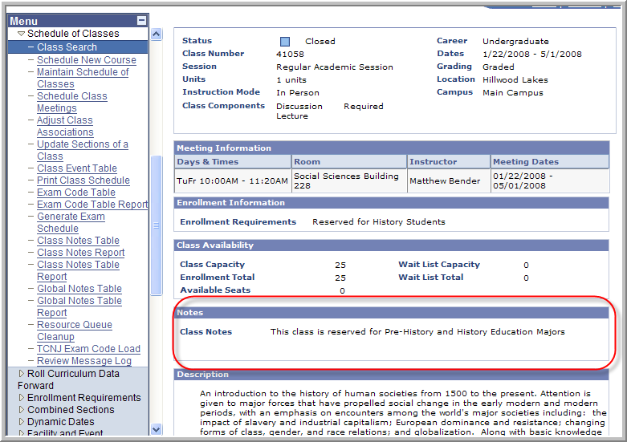

# How to Clear Cache

**Why do this?**

Each time you access a web page (i.e. move around the PeopleSoft components) you are storing those pages. Eventually this will drag down page loading time…which could be misconstrued as a system processing issue.

**Directions**

1. Open Internet Explorer 
2. Go to **Tools** > **Internet Options** and click on **Delete Files**.

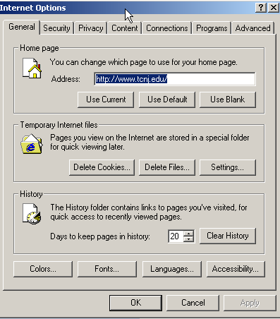

1. Make sure to check the Delete all offline context box and say OK. **This could take some time if you haven’t cleared cache in a while



**5.5 Reserve Capacity Special Notes**

1. After you have setup the reserve caps and students begin enrolling in the class, the Enrollment Total for each reserve capacity sequence line on the page will increment whenever students enroll who fit any of these categories.

2. Once a student is enrolled in the class, you cannot remove the reserve capacity. You can change existing reserve capacities and add new ones.

3. Reserve Caps can be rolled with the term roll.

Enrollment Requisite Summary

Navigation: main menu / curriculum management / enrollment requirements / enrollment requisite summary

Use the Enrollment Requisite Summary to review the construction of a requirement group. Enter the Enrollment Requirement Number.

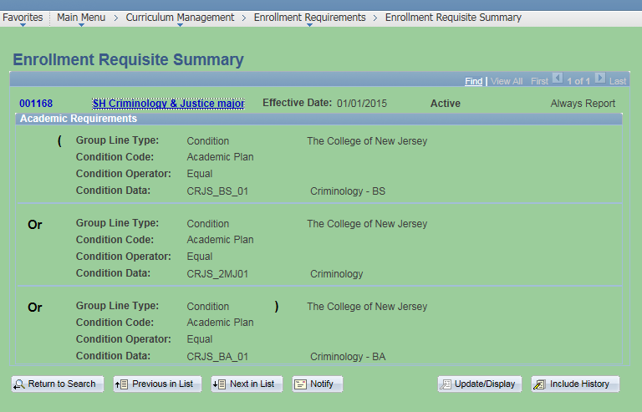

**How to Add Blended and Online Courses**

**For a BLENDED course:**

**Instruction mode:** Blended Learning

**Session Options:** Choose the appropriate term (Regular Academic Session, Summer ‘1’, Summer ‘2’, etc.) Blended Learning Session will no longer be an option.

**Room:** Include the Room # for the face-to-face meeting times. Do not add “On-line Study” for rooms.

**Days and Times:** Only include the face-to-face meeting dates and times.

**Notes:** Please add Note #23 to the PAWS listing to clarify: "This is a blended learning course that will have weekly face-to-face meetings with the remainder of the course completed through distance learning activities."

**For Blended Learning Labs:** Note #51, or customize your own: “This is a blended learning course that will have face-to-face labs with the lecture portion of the course completed through distance learning activities.”

**For an ONLINE course:**

**Instruction mode:** Online Learning

**Session:** Choose the appropriate term (Regular Academic Session, Summer ‘1’, Summer ‘2’, etc.) Blended Learning Session will no longer be an option.

**Room:** On-line Study

**Days and Times:** TBA or On-line Study

Notes: Please add Note #49: “This is an asynchronous online course and is delivered through the Canvas Learning Management System. No visits to campus are required, but you must have reliable access to the Internet and adequate time in your schedule to commit to the demands of the online coursework.”

**Caps**

Please discuss with your department chair/assistant dean/dean and adjust accordingly.

**Questions?**

Email Judi Cook, Director of the Office of Instructional Design at cookju@tcnj.edu.

C:\Documents and Settings\alcaro\Local Settings\Temporary Internet Files\Content.IE5\227W5WXA\MCj03562130000[1].wmf Need More Help?

Contact the Scheduling Office at schedule@tcnj.edu