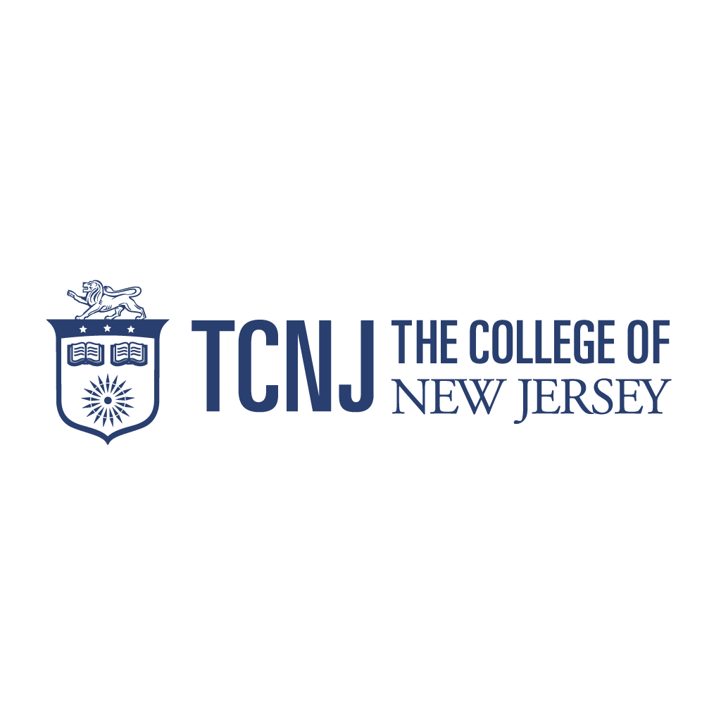

Mentored Internship Task Force
Fall 2014 – Summary Report
Members: Ashley Borders, Tammy Germana, Janet Gray, Debra Kelly,
Emilie Lounsberry, Michael Ochs, Jennifer Palmgren
Submission Date: December 19, 2014

Background Information:
The Mentored Internship Task Force (MITF) is one of the five Signature Experience Task Forces formed by Academic Affairs for Fall 2014. The charge to the task force was as follows:
While TCNJ is currently a best-practice institution with regard to Mentored Undergraduate Research, the adoption of our second signature experience gives us good reason to take a systematic look at how we are structuring mentored internship experiences for our students, particularly those for which we offer course credit. The Mentored Internship Task Force will pull together information on current internship programs and practices in various schools, through the Career Center, and within student affairs; consider how these experiences build upon students’ curricular work; examine best practice for undergraduate internships (both paid and unpaid) in Higher Education; and generate recommendations on how we might strengthen and scale up the mentored internship opportunities available to our students. The Task Force will recommend a standard minimum dataset to track our practice and progress.
During Fall 2014, the task force discussed and surveyed TCNJ practices, consulted national higher education resources, and compiled both immediate recommendations and items for further consideration. Before beginning any research, the task force first agreed upon a definition of mentored internships as posted on the TCNJ Career Center website, with an implied assumption of at least one faculty or on-site supervisor serving as a mentor:
“An academic internship is a form of experiential education that integrates knowledge and theory in the classroom with practical application and skill development in a profession setting. Students can earn academic credit, or there is some other connection to a degree-granting, educations institution. The internship is usually the length or equivalent of an academic term, may be part-time or full-time, paid or unpaid. An integral component of the experience that distinguishes it from other types of work is one of more forms of structured and deliberate reflection contained within learning agendas and objectives.” Collaboration of Internship Listserv members (Pittsburgh Technology Council & Messiah College), NACE, NSEE (http://career.tcnj.edu/students/jobs-and-internships/internships/)

Internships at TCNJ - Current Practices:
During the first task force meeting, members quickly identified broad variation of mentored internship activity across TCNJ – different processes, requirements, credit vs. not-for-credit policies, paid vs. unpaid opportunities, etc. As the task force members represent seven areas of TCNJ, a Qualtrics survey was developed to solicit current practices from all undergraduate departments and establish a baseline dataset.
Survey Findings
TCNJ Department Chairs received the survey via email, with follow up from the task force members. The survey sought to establish baseline information about internships at TCNJ as this does not exist. Survey questions asked about current internship requirements, processes, supervision, and mentorship.
The following data points summarize the survey results, reflecting the 20 undergraduate departments (out of 36 total) who submitted a complete survey. A copy of the survey and the full set of responses are enclosed at the end of this report.
- 35% of departments require an internship, with an additional 35% responding “not required, but highly encouraged.”
- In 70% of departments, students may complete credit and non-credit internships, with 20% reporting only credit internships are offered. The School of Engineering reported that summer internships are strongly encouraged but there is no credit offered.
- The process for enrolling in an internship varies across departments with regards to formality, approval, paper and online forms.
- 81% of departments indicated on-site supervisors are required, with one comment indicating that their department believed this to be college policy.
- On-site supervisors provide mentorship in addition to basic supervision, as indicated by 83% of responses, with the remaining 17% indicating supervision-only.
- Faculty visit students at their internship sites in 29% of the departments.
- While no departments offer training for faculty supervisors, 29% offer at least some amount of student training in preparation for internships.
- The number of times a faculty member meets with a student during an internship ranges from once a semester to once a week, or more on a need basis.
- 76% of departments survey students or require a report at the completion of an internship.
- Most departments require a minimum class level and 2.5 GPA or higher, with a majority also requiring pre-requisite coursework. Students must work 50 hours to earn one credit in most cases, however there is some confusion regarding college policy dictating these criteria (class level, GPA, credits).
- The extent to which evaluations and reflective assignments are required of students varies greatly among departments. Some internships require no evaluations or assignments, while others require one or more of the following: student’s assessment of their employer, on-site supervisor’s assessment of the student, written reflection pieces on their learning, journal of weekly reflections, detailed activity logs, presentation at the Celebration of Student Achievement, and/or a research paper related to their internship.
- Internship-specific webpages are maintained by half of the departments.

Best Practices in higher education
Several national and regional organizations in career development and experiential education provide guidelines and best practices for internships in higher education. In consultation with the Career Center, the task force reviewed current guides and best practice documents published by these leading organizations, including: the United States Department of Labor, National Association of Colleges and Employers (NACE), National Society of Experiential Education (NSEE), NJ Cooperative Education & Internship Association (NJCEIA), Council for the Advancement of Standards in Higher Education (CAS), Messiah College and the Greater Delaware Valley area (whose internship guide is regarded as a national model). The task force also sought best practices within TCNJ, reviewing Career Center resources and discussing internships with faculty and staff.
The following list summarizes the most common findings regarding best practices, where two or more organizations enforced this practice:
- Student training or orientation: Provide student interns with training to help them understand expectations of the work environment from dress code to professional ethics.
- Learning outcomes*: Articulate expected student learning outcomes for internships through internship syllabi.
- Employer training: Determine criteria for effective, inclusive internship sites and train appropriate internship personnel to ensure productive and appropriate learning opportunities for students.
- Faculty training: Faculty qualifications should include development of assessment skills, proper communication with students, enhancement of student learning, and management skills.
- Faculty-led assessment: Faculty should conduct regular assessments to determine to what degree the stated mission, goals, and student learning outcomes are being met.
- On-site supervision and evaluation: All internship employers should assign a supervisor to supervise and mentor the intern, provide periodic progress evaluations to the intern as well as a final evaluation to the intern and to the academic institution supervisor.
- Student evaluation of employer: Students should complete a standardized evaluation of their employer and submit it to their faculty supervisor for review. Colleges may use these evaluations to determine if an internship should be continued and/or strengthened.
- Student handbook: Student interns should be provided with a handbook (paper or electronic) to help navigate internship processes and questions.
- Flexible schedules: Encourage employers to offer flexible schedules to accommodate students' varied academic schedules.
- Site visits: College faculty and staff should be able to visit the internship sites, learn about the experiences students will have as interns, and build ongoing relationships.
- Internship manager: Have a college-wide or school-wide internship manager.
It is important to note the TCNJ Community Enhancement Internship Program (CEI) and its respective Program Manual exemplifies many of the national recommendations. The CEI Program is an on campus, paid internship program that exposes students to the business of higher education, has training components, reflection materials and evaluations.
*In addition to best practices, some national career development resources, such as the National Career Development Association (NCDA) share their research on career development, which could be helpful in informing learning outcomes related to mentored internships. Per the NCDA, there are three important facets to career development: personal social development, educational achievement and lifelong learning, and career management. They also identify three stages of career learning, including knowledge acquisition, application, and reflection.

Recommendations
The Mentored Internships Task Force recommends the following actions and other considerations to strengthen mentored internships and integrate best practices.
Short-term Recommendations:
- Update the TCNJ policy on internships and communicate policy to all faculty and staff. Currently, some confusion exists about minimum requirements, credit weight, and if an active policy is in writing.
- Explore the use of one central database to manage internships. This will allow for future tracking of internship activity as well as uniform processes and communication among participants. Lionslink, Collegiate Link, Canvas, PAWS, and Qualtrics are potential tools that can assist internships.
- Conduct student focus groups to seek improvements to the student experience. This will also provide an opportunity to verify if expectations of the students were realistic, if they learned significant knowledge, and their experience of the mentorship.
- Develop and require training for students prior to internships. Topics should include expectations of the workplace, the internship process, and maximizing the internship as a learning experience.
- Require all internships to have documented learning objectives.
Further considerations:
- Should faculty supervisors be required to have at least one meeting or contact with the on-site supervisor during the internship?
- Should internships require final evaluations from the faculty supervisor, the on-site supervisor, and the student?
- Explore mentored internship opportunities in areas that currently offer few internships. In some disciplines, such as STEM majors, research programs are more common. Are there opportunities to expand internships in these fields?
- Periodic feedback is valuable to the student’s learning experience, and can facilitate mentoring conversations. Should all internships require the student to have both a faculty and on-site supervisor? What minimum feedback should be provided to the student during the internship experience?
- As reinforcement of the learning experience, should all internships require at least one reflective assignment?

Submitted 12/18/14

